Bradley Tabbron (19063953) – Web Design Document

Section A: Directory Structure

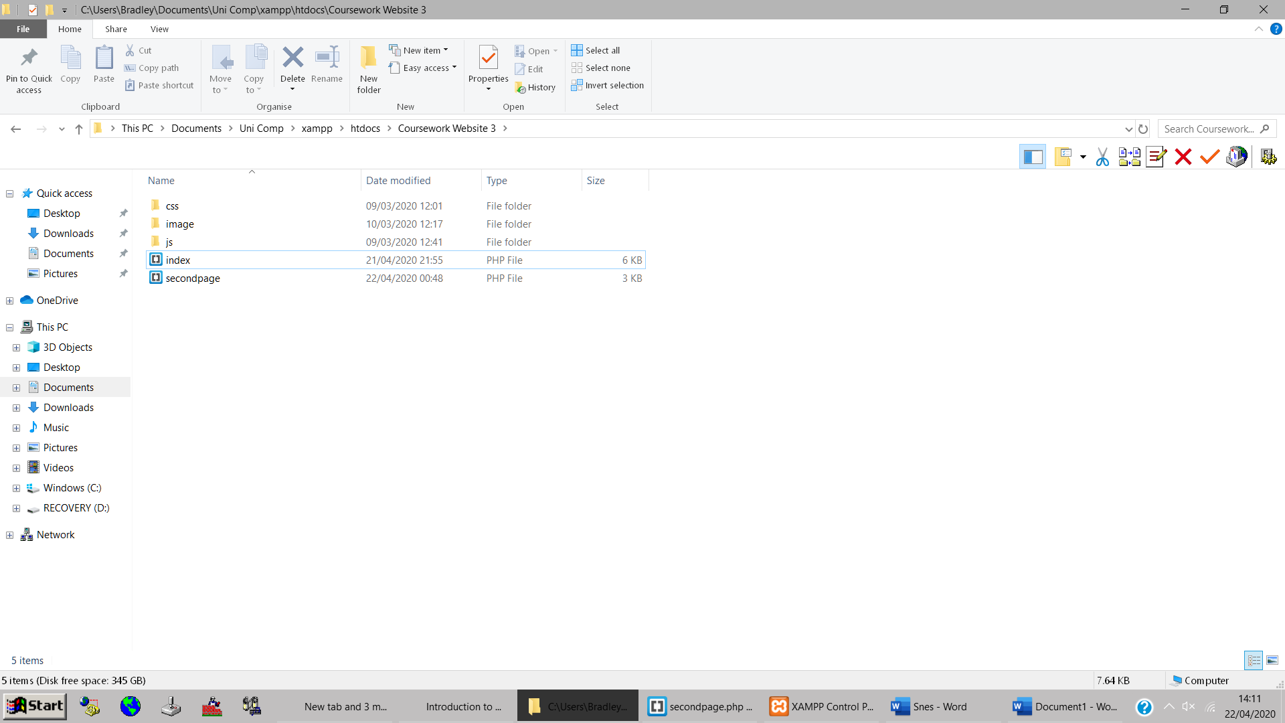

My directory consists of two php files and three folders each containing their relevant file/s.

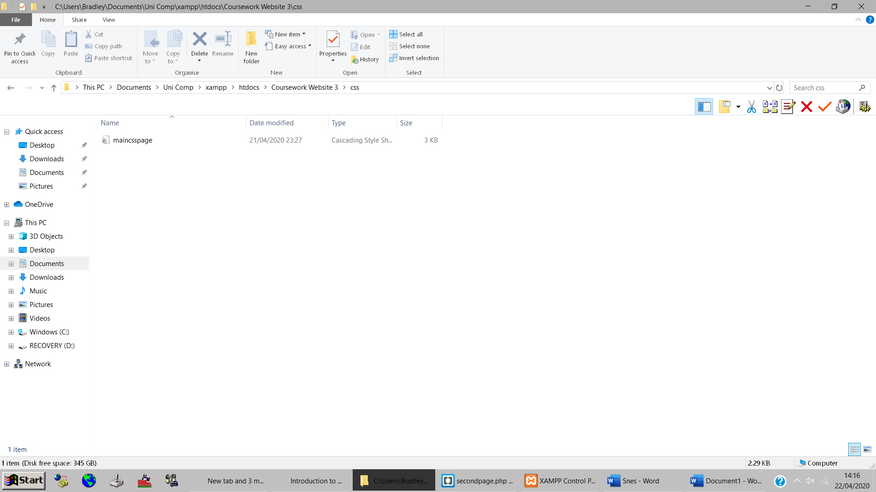

The CSS file.

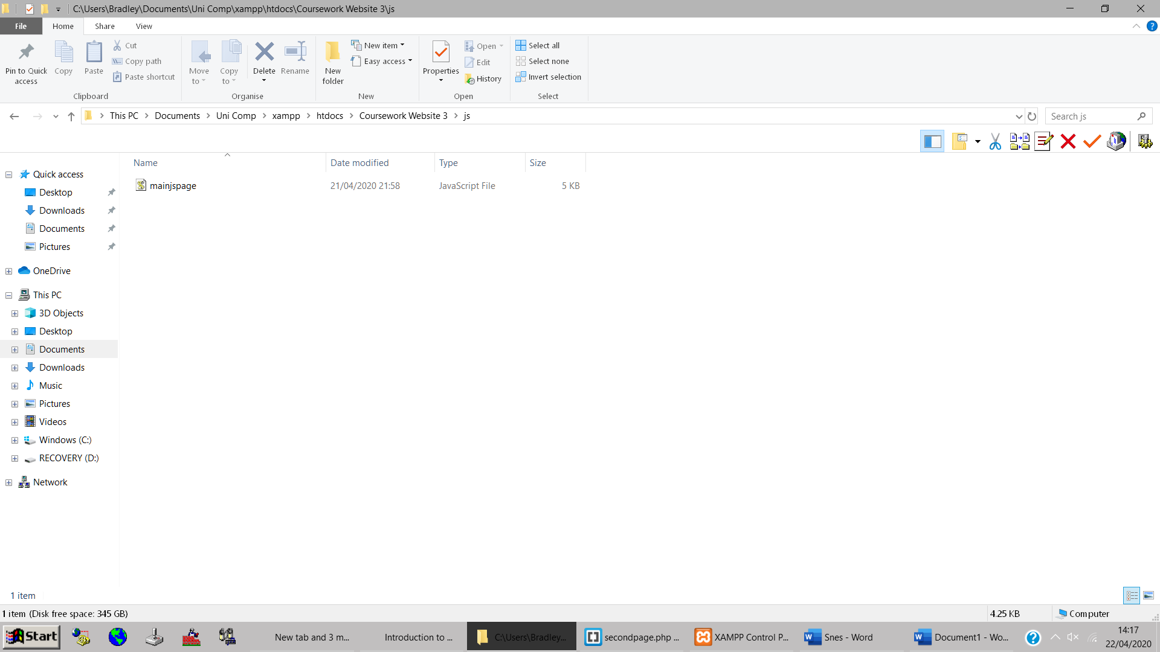

The Javascript file.

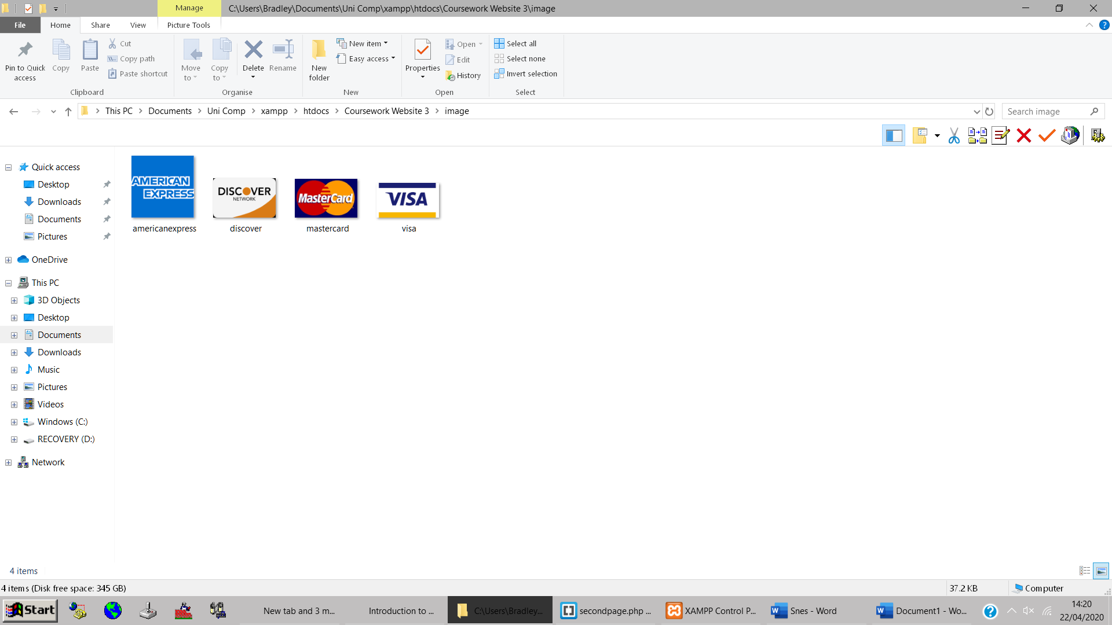

The image file.

Section B: Front Webpage Overview

My front page performs validation by changing the border colour of the associated box from grey to green indicating that this field is now valid. I think this is a more user friendly way to perform validation as it clearly communicates where the problem is without scaring the user. In my personal experience, less techy people can sometimes get a feeling that they’ve ‘broken something’ when an alert or message box appears so a form that will change colour when the input is valid is more easy to understand way.

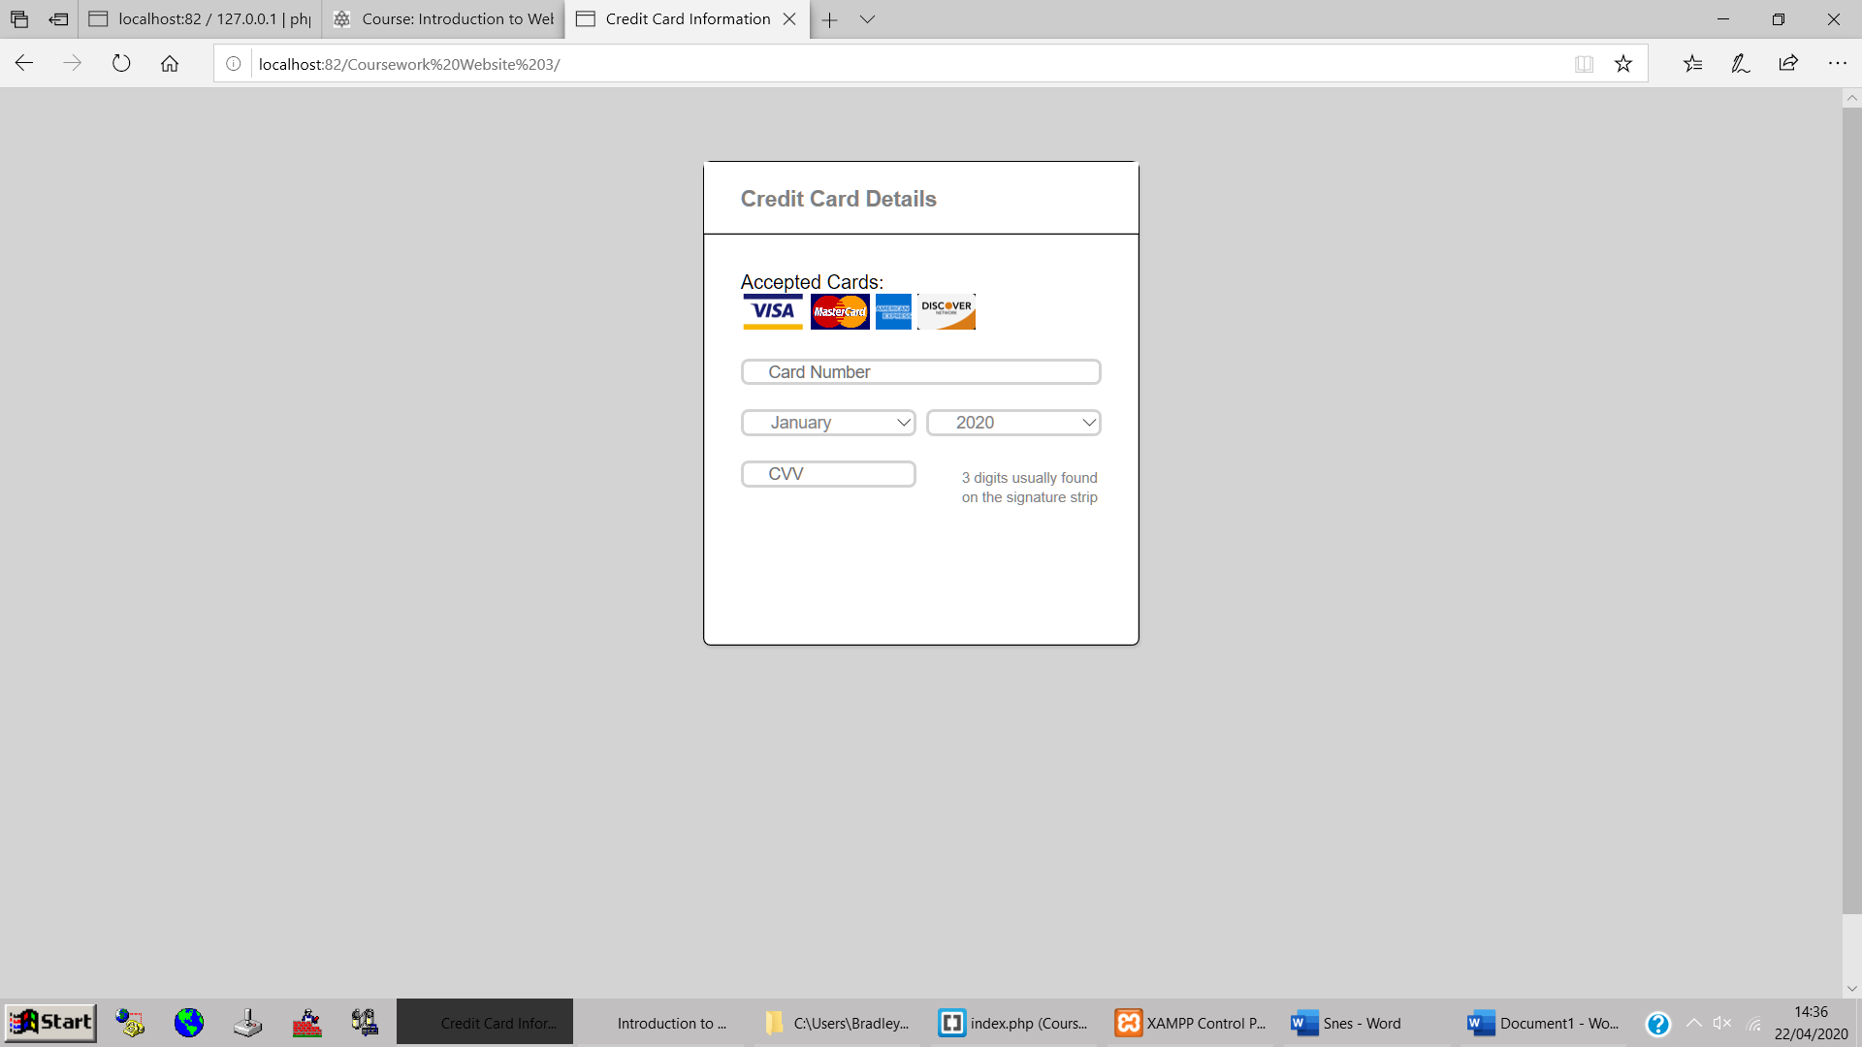

My front page

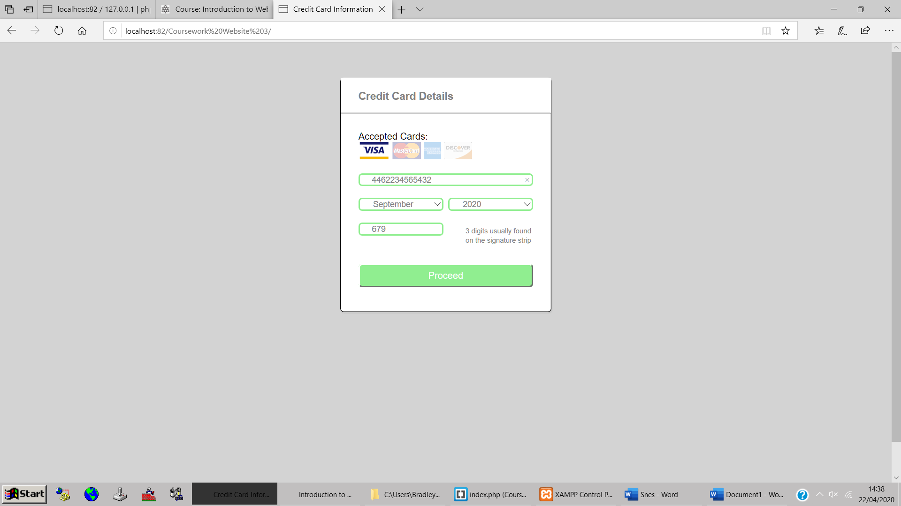

When all details are entered correctly the proceed button will appear.

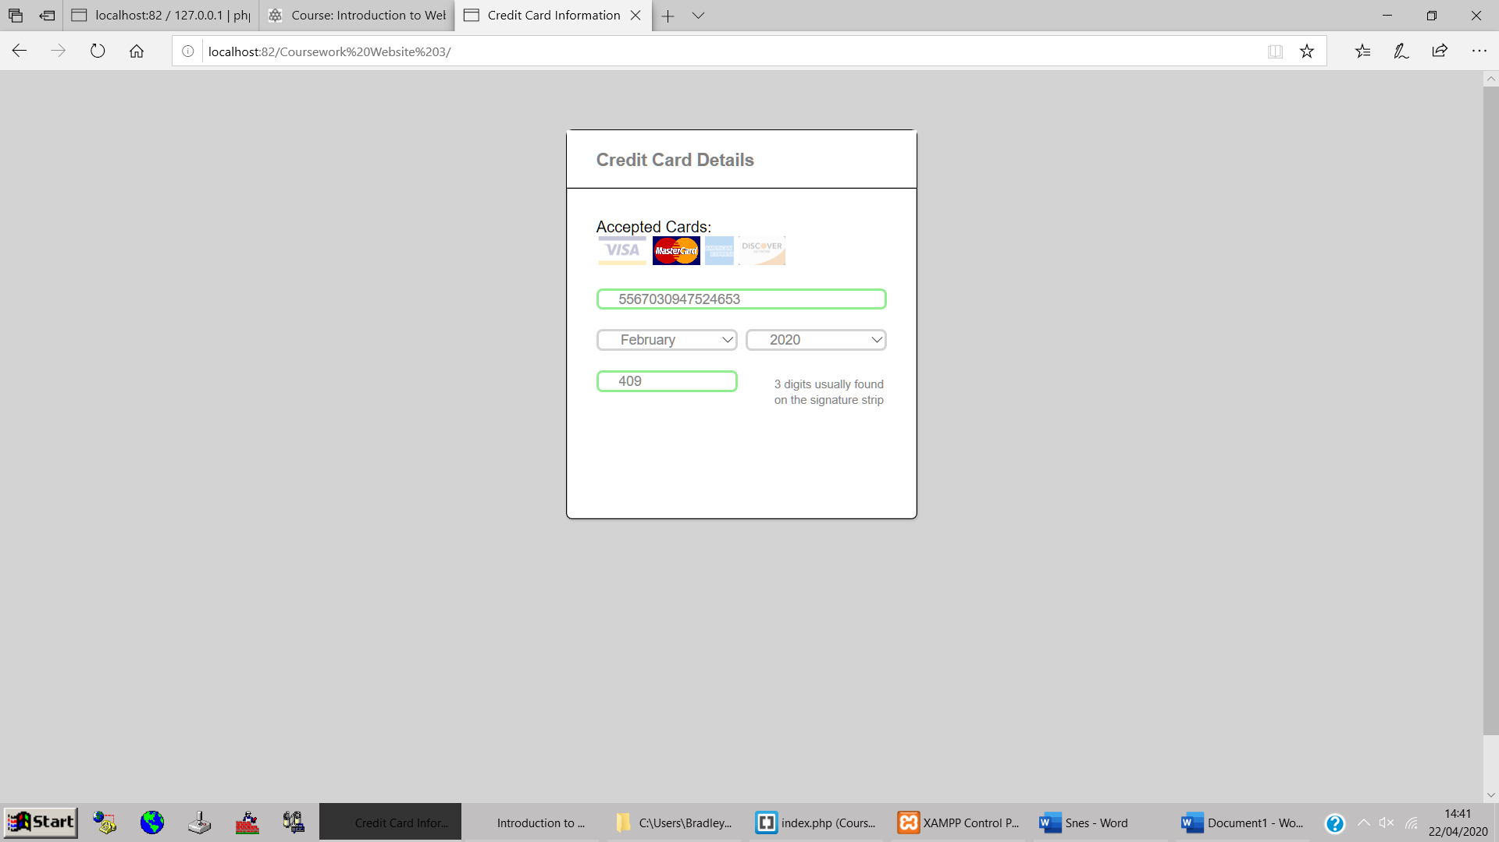

The form runs a validation check every time a key (including backspace) is pressed on the card number field and the CVV field or if the selection is changed on either the month or year field. This also shows how my form communicates to the user the problem with their form in this case the expiry date being in the past. The form will also not accept any letters as inputs either.

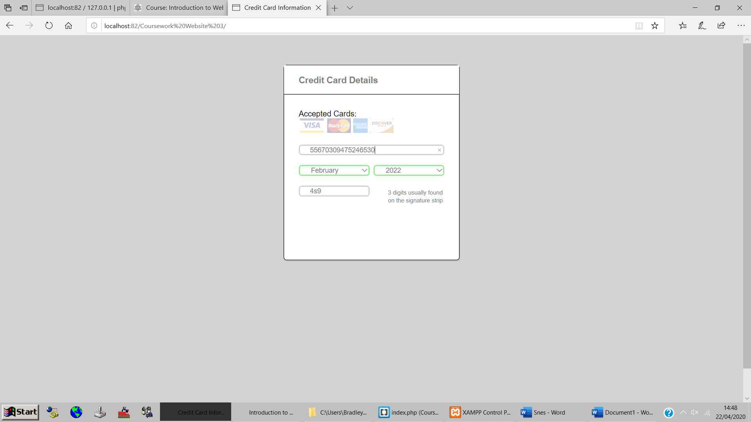

An extra digit has been added to the card number field and the ‘0’ has been replaced with an ‘s’ in the CVV form, invalidating both fields.

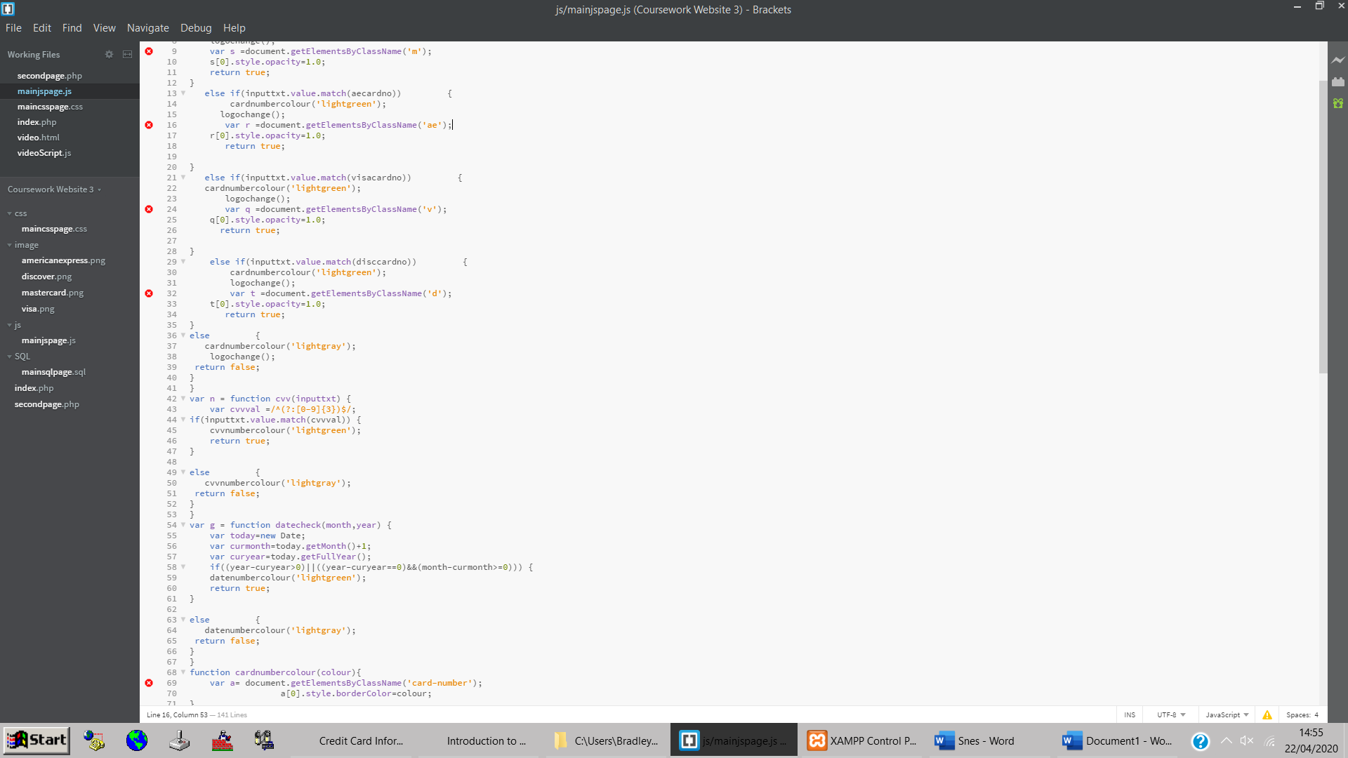

This is the validation check for the CVV field and Date field. The date field works by reading in the month and year selected, getting the current month and year and then working out if the date is not in the past. Line 58 shows this validation which **validates if** the year inputted by the user subtracted by the current year is greater than zero (ie, 2022-2020=2 which is greater than 0) **OR if** the inputted year subtracted by the current year is equal to zero **AND** the inputted month subtracted by the current month is greater than or equal to zero (ie, 06/2020, 2020-2020=0 and 06-04[at time of this report] = 2 which is greater than 0). This means that as of 04/2020 dates 04/2020; 12/2024; 09/2020 will be valid and dates 03/2020 will not be valid.

The CVV validation check makes any input valid so long as it consists of 3 characters and those 3 characters are in the range 0-9 (numeric values). My card number validation also works very similar to this with different values to validate.

Section C: Database

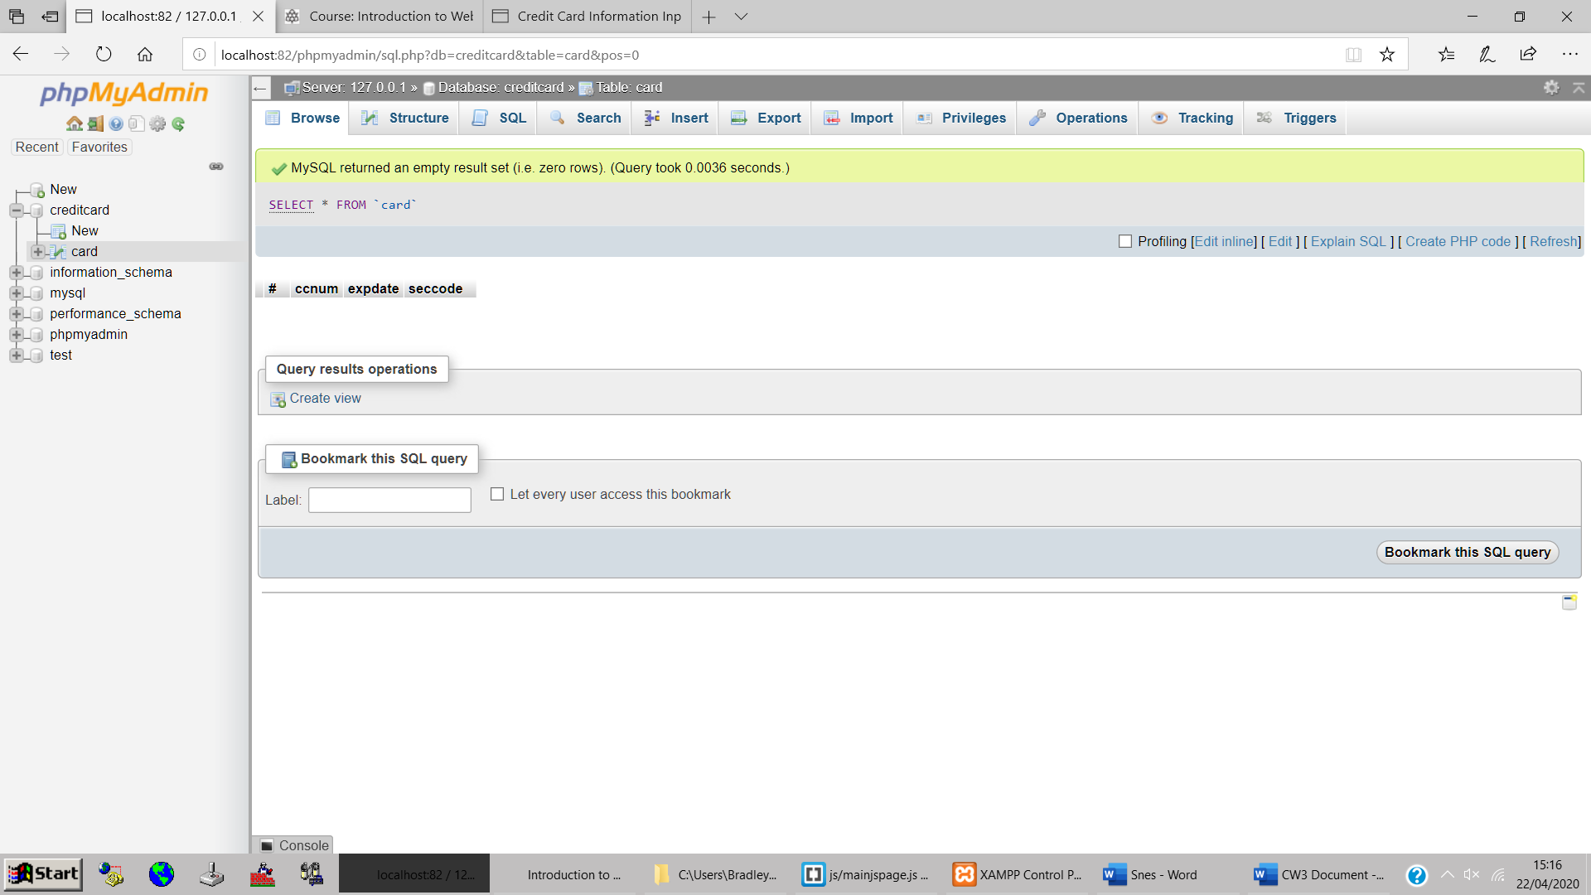

My database currently has 0 rows in it and I will add to the following to the database by clicking the proceed button. This will also load secondpage.php:

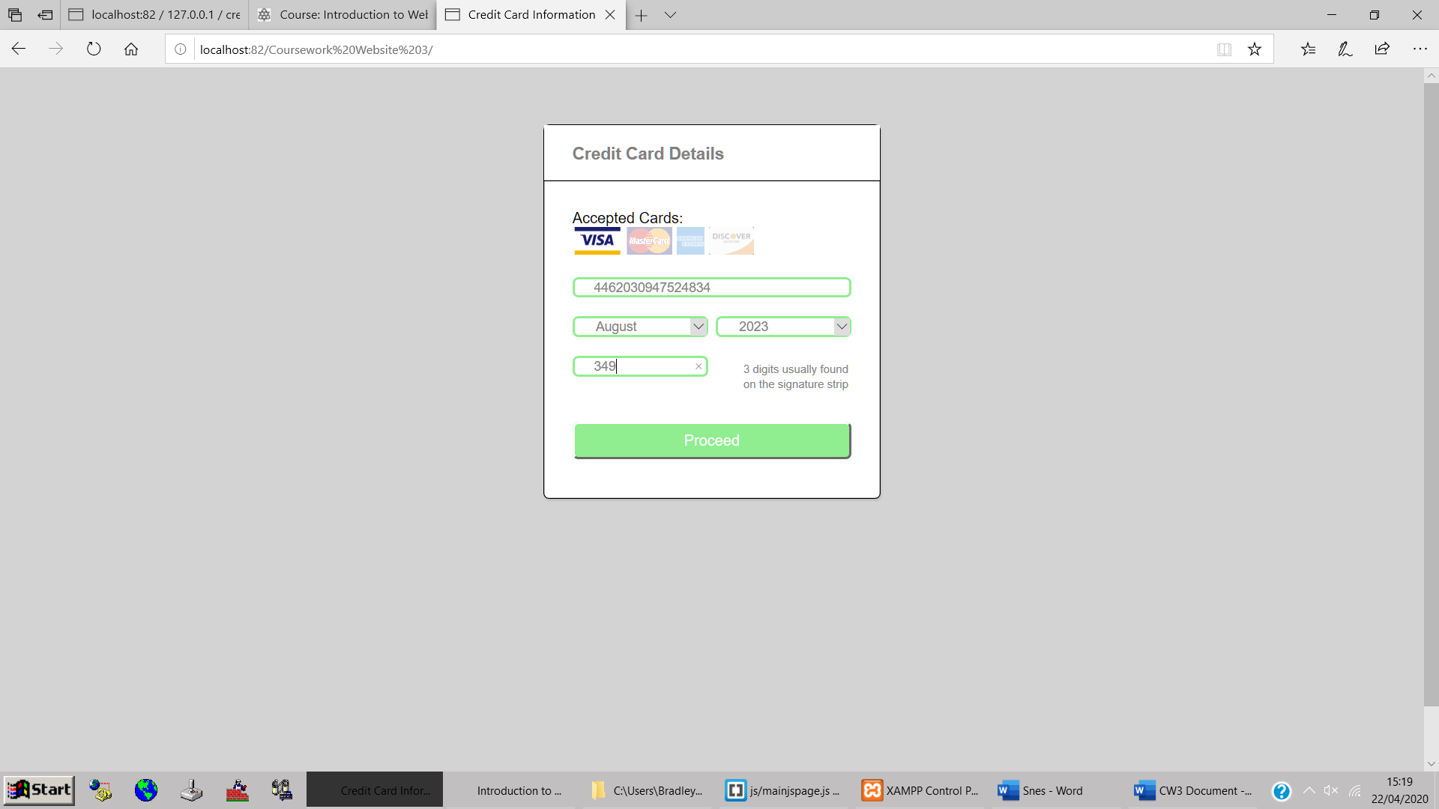

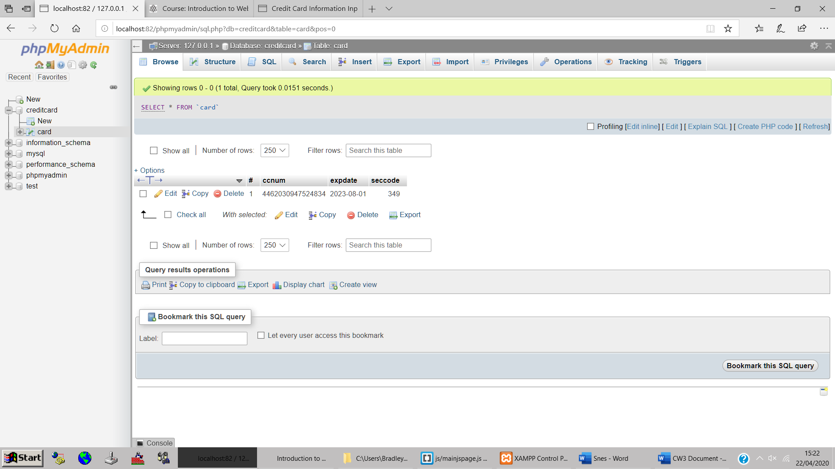

The database with the card details inputted into it.

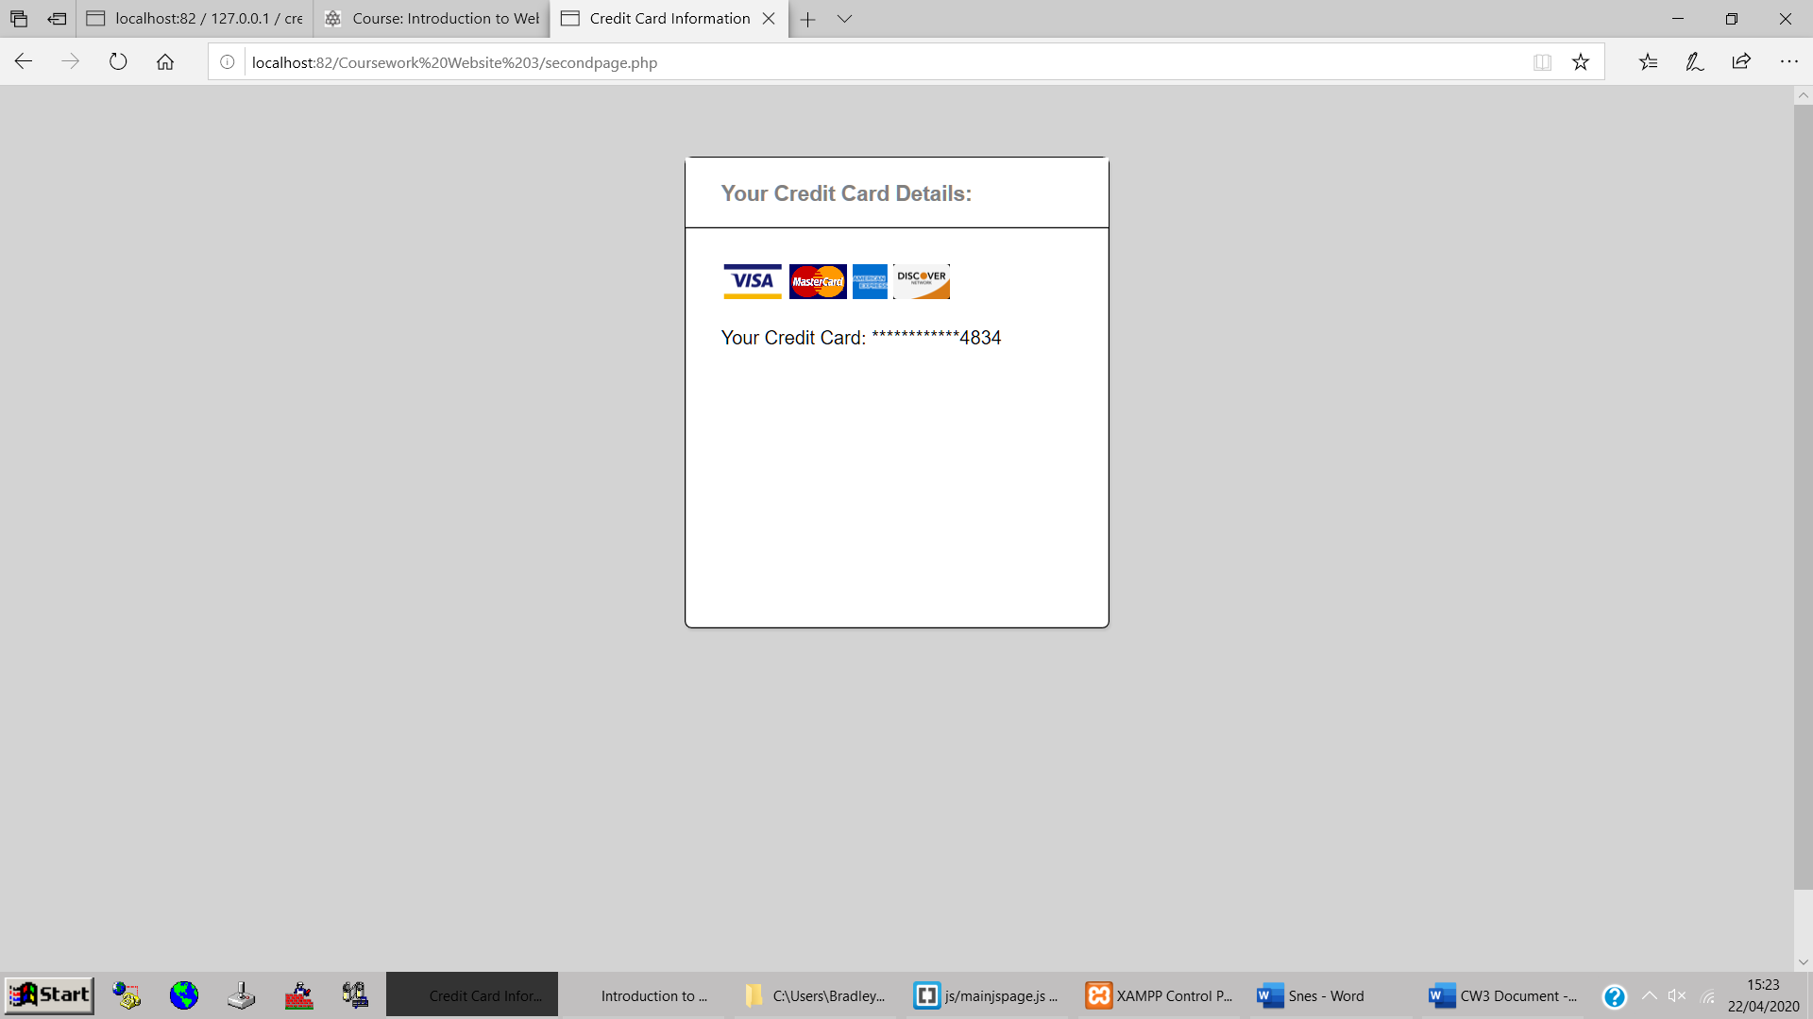

Second page showing the user the last four digits of their card details.

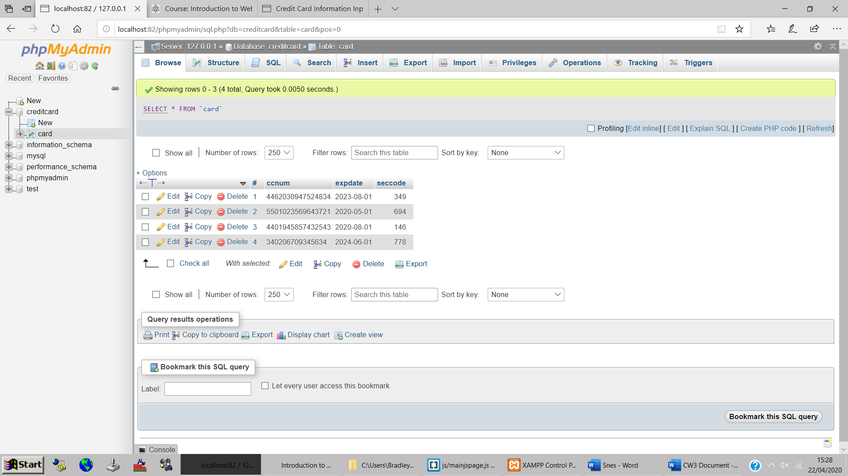

The database with some additional data in it.

Section D: Code Appendix

* index.php: Main page.
* secondpage.php: Page directed to after details have successfully been entered.
* maincsspage.css: Styling sheet used.
* mainjspage.java: Contains all the javascript.